ADAPTIVE DATA STRUCTURE SELECTION USING LARGE LANGUAGE MODELS FOR SECURE HEALTHCARE DATA PROCESSING

A Project Work/ Practice School Report submitted

to

MANIPAL ACADEMY OF HIGHER EDUCATION

for partial fulfilment of the requirement for

the award of the degree

of

BACHELOR OF TECHNOLOGY
in

INFORMATION TECHNOLOGY

Submitted by

Sayali Sachin Chorge
220911266
Under the guidance of

Dr. Shwetha Rai
Assistant Professor – Senior Scale
School of Computer Engineering
MIT Manipal



SCHOOL OF COMPUTER ENGINEERING

July 2026

DECLARATION
I hereby declare that this project work entitled Adaptive Data Structure Selection Using Large Language Models for Secure Healthcare Data Processing is original and has been carried out by me in the School of Computer Engineering of Manipal Institute of Technology, Manipal, under the guidance of Dr. Shwetha Rai, Assistant Professor Senior Scale, Internal Guide, School of Computer Engineering, M.I.T., Manipal. No part of this work has been submitted for the award of a degree or diploma either to this University or to any other Universities.

Place: Manipal
Date: 14/07/2026



Sayali Sachin Chorge
Reg No: 220911266
(Student Name and Signature)



SCHOOL OF COMPUTER ENGINEERING

Place:Manipal
Date: 14/07/2026

CERTIFICATE

This is to certify that the project titled Adaptive Data Structure Selection Using Large Language Models for Secure Healthcare Data Processing is a record of the bonafide work done by Sayali Sachin Chorge (Reg. No. 220911266) submitted in partial fulfilment of the requirements for the award of the Degree of Bachelor of Technology (B.Tech.) in INFORMATION TECHNOLOGY of Manipal Institute of Technology, Manipal, Karnataka, during the academic year 2025–2026.

Dr. Shwetha Rai Dr. Smitha N. Pai
Assistant Professor- Senior Scale Professor & Associate Dean,
School of Computer Engineering, School of Computer Engineering,
Manipal Institute of Technology, Manipal Manipal Institute of Technology, Manipal

ACKNOWLEDGMENTS

I express my sincere gratitude to the Director, Manipal Institute of Technology, Commander Dr. Anil Rana, the Dean, Dr. Radhika M Pai for providing me the opportunity to pursue my research topic.
I express my sincere gratitude and thank my Project Guide, Dr. Shwetha Rai, for her guidance, support, and valuable suggestions throughout the project work.

I also sincerely thank my Project Coordinator Dr. Diana Olivia and Laboratory In-Charge Ms. Asha for giving me this opportunity and resources to achieve the same.

I also thank the School of Computer Engineering, Manipal Institute of Technology, for providing the academic environment and resources required to complete this work.

I am grateful to all the faculty members, classmates, and well-wishers who supported me during the project.

ABSTRACT

Healthcare systems generate large volumes of patient data that are often incomplete, sparse, and dynamic in nature. Traditional database systems and fixed data structures primarily focus on storage and retrieval but are limited in their ability to infer missing information or adapt to changing data patterns. This limitation affects the accuracy and efficiency of healthcare decision-making, especially when only partial symptom information is available.

To address these challenges, this project aims to develop an intelligent and explainable healthcare diagnosis system that combines association rule mining, graph-based inference, similarity-based reasoning, and Large Language Model (LLM)-inspired decision support for improved disease prediction and healthcare data processing.

The proposed methodology follows a hybrid approach. Initially, healthcare data is pre-processed and transformed into a structured symptom matrix using one-hot encoding. Frequent symptom combinations are extracted using the Apriori algorithm, and association rules are generated and evaluated using metrics such as support, confidence, lift, conviction, and cosine similarity.
The discovered relationships are represented through a weighted adjacency list graph. Breadth-First Search (BFS) is then applied to infer missing symptoms from incomplete patient inputs. In the end, cosine similarity-based scoring is used to compare patient symptom profiles with disease profiles, while an LLM-based decision module is incorporated to enhance interpretability and reasoning.

The implementation successfully identified meaningful symptom associations and generated high-quality association rules. The graph-based representation efficiently modelled symptom relationships and enabled multi-level symptom inference. The BFS-based inference mechanism improved the handling of incomplete patient data, while cosine similarity effectively ranked potential diseases based on symptom matching.
The hybrid framework demonstrated improved robustness, explainability, and diagnostic capability compared to approaches relying on a single technique. These results indicate the effectiveness of combining data mining, graph traversal, and similarity-based reasoning for healthcare diagnosis.

The proposed system provides an accurate, scalable, and explainable framework for healthcare diagnosis using incomplete symptom data. By integrating association rule mining, graph-based inference, similarity scoring, and LLM-assisted reasoning, the system enhances healthcare decision support and improves diagnostic reliability.
I have used Python, Pandas, NumPy, Mlxtend (Apriori), Scikit-learn, Jupyter Notebook, and Large Language Models (LLMs) in this project.

Contents

List of Tables v
List of Figures vi
Abbreviations vii
Notations viii
- Introduction 1
  - Introduction 1
  - Motivation 2
  - Objective 2
  - System Specifications 3
  - Project Work Schedule 3
  - Organization of the Report 3
  - Contribution Summary 4
- Background Theory / Literature Review 5
  - Background Theory 5
2.1.1 Apriori Algorithm 5
2.1.2 Adjacency List Representation 7
2.1.3 Association Rule Mining 9
2.1.4 Breadth First Search 10
2.1.5 Cosine Similarity 11
2.1.6 Generative Pre-trained Transformer (GPT) Model 13
  - Literature Survey 16
  - Summary of Literature Review 17
  - Conclusions 17
- Methodology 18
  - Detailed Methodology 18
  - Assumptions Made 20
  - Design & Modelling 20
3.3.1 Data Acquisition and Preprocessing 20
3.3.2 Data Issues Identified 21
3.3.3 Data Preprocessing (with Techniques) 21
3.3.4 Workload Modelling and Monitoring 21
3.3.5 Techniques Used 22
3.3.6 Generative AI Module 24
3.3.7 Disease Prediction Module 25
3.3.8 Visualization Module 25
  - Tools Used 25
  - Conclusions 25
- Result Analysis 26
  - Results 26
4.1.1 Dataset Analysis 26
4.1.2 Disease Distribution Analysis 27
4.1.3 Symptom Frequency Analysis 27
4.1.4 Symptom Relationship Analysis 28
4.1.5 Adaptive Data Structure Selection 29
4.1.6 GenAI-Assisted Symptom Expansion 30
  - Discussion 32
  - Limitations 34
  - Conclusions 35
- Conclusion and Future Scope 36
  - Summary 36
  - Conclusions 36
  - Future Scope 36
  - Contribution Summary 37
References 38
Project Details 40
Plagiarism Report 41

List of Tables

1.1 Details of target specification where the project is executed 3
1.2 Details of the project work schedule in phases 3
2.1 Details of the literature survey highlighting contribution and research gap 16
4.1 Details of the dataset's nature 30

List of Figures

3.1 Details of methodology used as depicted in system workflow 19
3.2 Algorithm for Apriori 22
3.3 Algorithm for Association Rule Mining 22
3.4 Algorithm for Threshold Tuning 23
3.5 Algorithm for Adjacency List as represented by Graph 23
3.6 Algorithm for Breadth-First Searching 23
3.7 Algorithm for Cosine Similarity 24
3.8 Algorithm for Generative AI Module 24
4.1 Details of Dataset Density 26
4.2 Details of Disease Distribution in the Dataset 27
4.3 Details of Frequently Occurring Symptoms in the Dataset 28
4.4 Details of Symptom Relationship Graph 29
4.5 Details of the Dataset's Metrics 30
4.6 Details of the User Input Window to enter symptoms 30
4.7 Details of the Output Displayed by the Model 31
4.8 Details of the Predictions Displayed by Generative AI 31
4.9 Details of the GenAI-Assisted Explanation of the Output 32

vi.
Abbreviations

AI | Artificial Intelligence
LRU | Least Recently Used
LLM | Large Language Model
GPT | Generative Pre-trained Transformer
BFS | Breadth-First Search
DFS | Depth-First Search
API | Application Programming Interface
CSV | Comma-Separated Values
RAM | Random Access Memory
CPU | Central Processing Unit
OS | Operating System
EHR | Electronic Health Record
ML | Machine Learning

vii.
Notations

G = (V, E) | Graph consisting of vertices and edges
V | Set of vertices (symptoms)
E | Set of edges (symptom relationships)
A→B | Association rule
Supp (A) | Support of itemset A
Conf (A→B) | Confidence of association rule
Lift (A→B) | Lift measure
Conv (A→B) | Conviction measure
CS (A, B) | Cosine similarity between vectors A and B
P | Patient symptom vector
D | Disease symptom vector
Q | Queue used during BFS traversal
n | Number of transactions/patient records
m | Number of symptoms/features
d Dataset density
s Dataset sparsity

viii.

CHAPTER 1

INTRODUCTION

Introduction
Healthcare systems generate large volumes of complex and continuously evolving data, making efficient data management and processing a critical requirement. The increasing adoption of electronic health records, clinical decision support systems, and intelligent healthcare applications has created the need for computational techniques that can process medical information accurately and efficiently. Artificial Intelligence (AI), machine learning, and data mining techniques have significantly improved healthcare by enabling disease prediction, patient monitoring, and decision support. However, the effectiveness of these systems depends not only on the algorithms employed but also on the underlying data structures used for storing, organizing, and retrieving healthcare data [1]. Efficient data organization plays a vital role in ensuring faster access, reduced computational overhead, and improved scalability in healthcare applications [1].
Data structures form the backbone of modern software systems by enabling efficient storage, retrieval, and manipulation of information. In healthcare applications, selecting an appropriate data structure directly impacts the performance of disease prediction systems, patient record management, and knowledge discovery [2]. Traditional data structures such as arrays, linked lists, trees, graphs, and hash tables are designed to optimize specific operations based on the nature of the data and access patterns [2]. Association rule mining techniques, particularly the Apriori algorithm, have been widely adopted to discover meaningful relationships among symptoms and diseases, while graph-based representations efficiently model complex symptom-disease associations in sparse datasets [3]. Similarity-based methods further enhance prediction by identifying diseases with symptom patterns closely matching patient inputs. Together, these techniques provide a strong foundation for developing intelligent and explainable healthcare systems [8].
Despite their advantages, conventional data structures exhibit several limitations when applied to dynamic and real-world healthcare datasets [6]. Most existing systems rely on fixed data structures that remain unchanged regardless of variations in dataset density, sparsity, or user query patterns. Such static approaches often lead to inefficient memory utilization, increased processing time, and reduced prediction accuracy when handling incomplete or irregular patient information [4]. Learned data structures and adaptive indexing techniques have attempted to address these challenges by improving data organization during runtime [5]. However, these methods primarily focus on indexing performance and often lack robustness, flexibility, and explainability when dealing with sparse healthcare data and complex symptom relationships [7]. Consequently, there remains a need for intelligent systems capable of adapting to varying data characteristics while maintaining high prediction accuracy and interpretability.
To overcome these limitations, this work proposes a hybrid healthcare disease prediction system that integrates association rule mining, graph-based inference, and similarity-based reasoning.
The proposed system utilizes the Apriori algorithm to discover symptom associations, constructs graph representations to model relationships among symptoms and diseases, and employs cosine similarity to generate ranked disease predictions even when patient information is incomplete [9]. Furthermore, the framework incorporates adaptive data structure selection, enabling the system to choose appropriate data representations based on dataset characteristics such as sparsity and density, thereby improving computational efficiency [10]. By combining explainable inference techniques with adaptive data organization, the proposed approach aims to enhance prediction accuracy, efficiently manage incomplete healthcare data, and provide reliable decision support for intelligent healthcare applications.

Motivation
Healthcare datasets are inherently complex, often containing incomplete, sparse, and noisy data [14]. Traditional database systems are designed primarily for storage and retrieval, but they lack the ability to infer missing information or adapt dynamically to changing data patterns [15]. This limitation becomes critical in diagnostic scenarios where decisions must be made even with partial symptom information. Association rule mining provides a way to uncover hidden relationships between symptoms, while graph-based models allow efficient representation of these relationships in sparse datasets [7],[14]. Additionally, similarity measures such as cosine similarity are widely used in pattern recognition and recommendation systems to compare data effectively [10]. Recent advances in intelligent systems and Large Language Models (LLMs) have demonstrated the potential for combining reasoning and data-driven approaches [11],[12]. Motivated by these developments, this project aims to integrate data mining, graph traversal, and similarity-based reasoning into a unified system that can improve diagnostic accuracy and provide interpretable results [13].

Objective
- To develop a hybrid intelligent disease diagnosis system by integrating association rule mining, graph-based representation, and similarity-based prediction techniques.
- To extract frequent symptom patterns from healthcare datasets using the Apriori algorithm.
- To generate meaningful association rules and evaluate them using performance metrics such as support, confidence, lift, conviction, and cosine similarity.
- To model the discovered symptom-disease relationships using a weighted adjacency list graph for efficient storage and traversal.
- To perform symptom inference using the Breadth-First Search (BFS) algorithm to expand incomplete patient symptom inputs.
- To apply similarity-based scoring for identifying and ranking the most probable diseases based on patient symptoms.
- To improve the system's capability to handle incomplete and sparse healthcare data through graph-based reasoning and provide accurate and interpretable disease predictions.

System Specifications

The implemented project uses the specifications shown in the below in Table 1.1.

Parameter | Value
Operating System | Windows 10/11 or Ubuntu 20.04+
Programming Language | Python 3.10+
Development Environment | Jupyter Notebook
Libraries used | Pandas, NumPy, Scikit-learn, Mlxtend, Matplotlib
Processor | Intel Core i5 or higher
RAM | Minimum 8 GB (16 GB Recommended)
Dataset Source | Healthcare Symptoms–Disease Classification Dataset (Kaggle)

Table 1.1 Details of target specification where the project is executed.

Project Work Schedule

The project was completed in phases, beginning with dataset analysis and environment setup, followed by symptom data preprocessing and one-hot encoding. The Apriori algorithm was implemented for frequent symptom pattern discovery and association rule mining. A weighted symptom graph was constructed, and finally, BFS-based inference and cosine similarity were integrated to develop a hybrid disease prediction system.

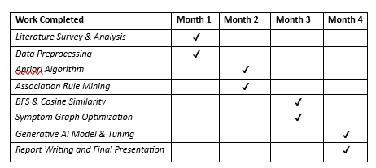

Table 1.2 Details of the project work schedule in phases.

Organization of the Report

Chapter 2 presents the background theory and literature review. Chapter 3 describes the implemented methodology, including data collection, algorithms used and model training. Chapter 4 presents the real generated results and discussion. Chapter 5 concludes the work and presents future scope.

Contribution Summary

This is an individual project. The complete workflow, including the data collection, preprocessing, algorithms optimization, figure generation, model training, and report generation was carried out by the student.

CHAPTER 2

BACKGROUND THEORY / LITERATURE REVIEW
The current chapter provides the theoretical and literature background associated with the
diagnosis of skin cancer through deep learning algorithms. Specifically, the advancements in
artificial intelligence, machine learning, convolutional neural network algorithms, hybrid
deep learning algorithms, and transformer-based approaches that have been used in medical
image analysis is highlighted.

Background Theory
2.1.1 Apriori Algorithm
The Apriori Algorithm serves as one of the fundamental techniques for association rule mining and frequent itemset discovery in large transactional datasets [16]. It is widely used in healthcare analytics, market basket analysis, recommendation systems, and disease prediction systems to identify hidden relationships among data items. Below are some of the salient characteristics that define it:
- Apriori identifies frequent itemsets by iteratively generating candidate itemsets and pruning those that do not satisfy the minimum support threshold. It operates based on the Apriori Property [16], which states that:
$$\text{If an itemset is frequent, then all of its subsets must also be frequent.}$$
- The support measure is used to determine how frequently an itemset appears in the dataset. It is calculated as:
$$Support(X)=\frac{Count(X)}{N}$$where
$$Count(X)→\text{Number of transactions containing itemset }X \\ N→\text{Total number of transactions}$$
- Candidate itemsets are generated from previously discovered frequent itemsets. The support value of each candidate itemset is compared against the minimum support threshold:
$$Support(X)≥MinSup$$
where
$$MinSup→\text{Minimum support threshold} \\ X→\text{Candidate itemset}$$
- Once frequent itemsets are discovered, association rules are generated in the form [17]:
$$X→Y$$
where
$$X∩Y=∅ \\ X,Y⊆I \\ I→\text{Set of all items}$$
- The strength of an association rule is measured using Confidence, which indicates how often itemset $Y$appears when itemset $X$is present [18]:
$$Confidence(X→Y)=\frac{Support(X∪Y)}{Support(X)}$$
where
$$Support(X∪Y)→\text{Support of the combined itemset} \\ Support(X)→\text{Support of the antecedent}$$
- Another important measure used to evaluate association rules is Lift, which determines the degree of dependence between two itemsets [18]:
$$Lift(X→Y)=\frac{Confidence(X→Y)}{Support(Y)}$$
A lift value greater than 1 indicates a positive association, while a value less than 1 indicates a negative association.
- To further assess rule quality, Conviction can be computed as [18]:
$$Conviction(X→Y)=\frac{1-Support(Y)}{1-Confidence(X→Y)}$$
Higher conviction values indicate stronger implication relationships between itemsets.
- The iterative generation and pruning mechanism of Apriori significantly reduces the search space by eliminating infrequent itemsets early in the process. This makes it suitable for discovering meaningful symptom-disease relationships in healthcare datasets, where frequently co-occurring symptoms can be used for disease prediction and clinical decision support.

2.1.2 Adjacency List Representation
Adjacency List is a graph data structure used to represent relationships between vertices by storing a list of neighbouring vertices for each node [19]. It is particularly suitable for sparse graphs where the number of edges is significantly smaller than the maximum possible number of edges [20]. In healthcare systems, adjacency lists can efficiently represent symptom-disease relationships and symptom co-occurrence networks.
- An adjacency list represents a graph $G$as:
$$G=(V,E)$$
where
$$V→\text{Set of vertices} \\ E→\text{Set of edges}$$
- For each vertex $v∈V$, a list of adjacent vertices is maintained [19]:
$$Adj(v)=\{u∣(v,u)∈E\}$$
where
$$Adj(v)→\text{Neighbors of vertex }v \\ u→\text{Adjacent vertex}$$
- The total memory requirement of an adjacency list is proportional to the number of vertices and edges [19]:
$$Space=O(V+E)$$
where
$$V→\text{Number of vertices} \\ E→\text{Number of edges}$$
This makes adjacency lists more memory-efficient than adjacency matrices for sparse datasets.
- The degree of a vertex is determined by the number of adjacent vertices:
$$Degree(v)=∣Adj(v)∣$$
where
$$∣Adj(v)∣→\text{Number of neighboring vertices}$$
- Edge insertion can be performed by adding a vertex to the adjacency list:
$$Adj(u)=Adj(u)∪\{v\} \\ Adj(v)=Adj(v)∪\{u\}$$
for an undirected graph.
- Traversal algorithms such as Breadth First Search (BFS) and Depth First Search (DFS) operate efficiently on adjacency lists with time complexity [20]:
$$O(V+E)$$
which is significantly lower than matrix-based traversal for sparse graphs.
- In the proposed healthcare system, symptoms are represented as graph vertices and symptom associations are represented as edges. For example:
$$Fever→\{Cough,Headache,Fatigue\} \\ Cough→\{Fever,Sore Throat\}$$
This representation enables efficient symptom expansion and disease prediction.
- Adjacency lists are selected when the graph sparsity ratio exceeds a predefined threshold:
$$SparsityRatio=\frac{E}{\frac{V(V-1)}{2}}$$
where
$$E≪\frac{V(V-1)}{2}$$
indicates a sparse graph.
- In the GPT-based adaptive framework, the model recommends an adjacency list whenever the symptom graph contains relatively few connections compared to the total possible connections, thereby reducing memory consumption and improving traversal efficiency [19].
- The ability of adjacency lists to efficiently store sparse healthcare graphs makes them highly suitable for symptom relationship modeling, disease inference, and adaptive data structure selection systems [20].

2.1.3 Association Rule Mining
Association Rule Mining is a data mining technique used to discover hidden patterns among items in large datasets [21]. In healthcare applications, it helps identify symptom-disease associations, co-occurring medical conditions, and treatment patterns. The technique generates rules that describe how the occurrence of one set of items influences the occurrence of another.
- Association rules are represented in the form:
$$X→Y$$
where
$$X→\text{Antecedent (If part)} \\ Y→\text{Consequent (Then part)} \\ X∩Y=∅$$
- The frequency of occurrence of an itemset is measured using Support [18]:
$$Support(X→Y)=\frac{Count(X∪Y)}{N}$$
where
$$Count(X∪Y)→\text{Number of transactions containing both }X\text{ and }Y \\ N→\text{Total number of transactions}$$
- The reliability of an association rule is measured using Confidence [18]:
$$Confidence(X→Y)=\frac{Support(X∪Y)}{Support(X)}$$
where
$$Support(X)→\text{Support of antecedent }X$$A higher confidence value indicates a stronger rule.
- The dependency between itemsets is evaluated using Lift [18]:
$$Lift(X→Y)=\frac{Confidence(X→Y)}{Support(Y)}$$
where
$$Lift>1→\text{Positive correlation} \\ Lift=1→\text{Independent relationship} \\ Lift<1→\text{Negative correlation}$$
- Another useful metric is Conviction, which measures the implication strength of a rule [18]:
$$Conviction(X→Y)=\frac{1-Support(Y)}{1-Confidence(X→Y)}$$
- Association Rule Mining enables the discovery of symptom combinations frequently associated with specific diseases. These rules can be utilized to provide explainable disease predictions and improve clinical decision support systems.

2.1.4 Breadth First Search
Breadth First Search (BFS) is a graph traversal algorithm used to explore all neighboring nodes level by level before moving to deeper levels. In healthcare symptom networks, BFS can be used to identify related symptoms, discover disease pathways, and expand symptom relationships [22].
- BFS traverses a graph by visiting all adjacent vertices of a node before proceeding to the next level [20].
- Let the graph be represented as:
$$G=(V,E)$$where
$$V→\text{Set of vertices (symptoms)} \\ E→\text{Set of edges (relationships)}$$
- BFS starts from a source node $s$and explores all reachable vertices using a queue data structure.

The traversal process can be represented as:
$$Visited=\{s\} \\ Queue=[s]$$
For each node $u$removed from the queue:
$$∀v∈Adj(u)$$
If $v$is unvisited:
$$Visited=Visited∪\{v\} \\ Queue=Queue∪\{v\}$$
where
$$Adj(u)→\text{Adjacent vertices of node }u$$
- The shortest path distance from source node $s$to a vertex $v$is [22]x:
$$Distance(v)=Distance(u)+1$$
where $u$is the predecessor of $v$.
- The time complexity of BFS is:
$$O(V+E)$$
where
$$V→\text{Number of vertices} \\ E→\text{Number of edges}$$
- BFS is particularly useful in symptom-disease graphs because it can efficiently identify neighbouring symptoms and expand user symptom inputs to improve disease prediction accuracy.

2.1.5 Cosine Similarity
Cosine Similarity is a similarity measure used to determine how closely two vectors are related by measuring the cosine of the angle between them [23]. In disease prediction systems, it is commonly used to compare a patient's symptom vector with known disease symptom vectors.
- Cosine Similarity evaluates similarity irrespective of vector magnitude and focuses on directional similarity [23].
The cosine similarity between two vectors $A$and $B$is given by:
$$CosineSimilarity(A,B)=\frac{A⋅B}{∥A∥∥B∥}$$
where
$$A⋅B=\sum_{i=1}^{n}{A_{i}}B_{i}$$
is the dot product of vectors.
$$∥A∥=\sqrt{\sum_{i=1}^{n}{A_{i}^{2}}}$$
is the magnitude of vector $A$.
$$∥B∥=\sqrt{\sum_{i=1}^{n}{B_{i}^{2}}}$$
is the magnitude of vector $B$.
- The similarity score ranges between:
$$-1≤CosineSimilarity≤1$$
For symptom vectors containing non-negative values:
$$0≤CosineSimilarity≤1$$
Where:
$$1→\text{Perfect similarity} \\ 0→\text{No similarity}$$
- Given a patient symptom vector $P$and disease symptom vector $D$:
$$Similarity(P,D)=\frac{\sum_{i=1}^{n}{P_{i}}D_{i}}{\sqrt{\sum_{i=1}^{n}{P_{i}^{2}}}\sqrt{\sum_{i=1}^{n}{D_{i}^{2}}}}$$
- Diseases are ranked according to their cosine similarity scores, and the disease with the highest similarity value is considered the most probable diagnosis.
- The ability of cosine similarity to efficiently compare high-dimensional symptom vectors makes it highly suitable for healthcare recommendation and disease prediction systems.

2.1.6 Generative Pre-trained Transformer (GPT) Model
The Generative Pre-trained Transformer (GPT) is a Large Language Model (LLM) based on the Transformer architecture. It is designed to understand and generate human-like text by learning contextual relationships between words from large-scale datasets. In healthcare applications, GPT models can assist in symptom interpretation, disease explanation, recommendation generation, and adaptive data structure selection based on dataset characteristics [24].
- GPT utilizes the Transformer architecture, which relies on a self-attention mechanism to capture long-range dependencies between tokens in a sequence without requiring recurrent neural networks [24].
- Given an input sequence of tokens:
$$X=\{x_{1},x_{2},x_{3},…,x_{n}\}$$
the model converts each token into a dense vector representation called an embedding:
$$E=Embedding(X)$$
where
$$E→\text{Input embedding matrix} \\ X→\text{Input token sequence}$$
- The core component of GPT is the Scaled Dot Product Attention mechanism:
$$Attention(Q,K,V)=Softmax\left(\frac{QK^{T}}{\sqrt{d_{k}}}\right)V$$
where
$$Q→\text{Query matrix} \\ K→\text{Key matrix} \\ V→\text{Value matrix} \\ d_{k}→\text{Dimension of key vectors}$$
- To capture multiple contextual relationships simultaneously, GPT employs Multi-Head Attention [24]:
$$MultiHead(Q,K,V)=Concat(head_{1},…,head_{h})W^{O}$$
where
$$head_{i}=Attention(QW_{i}^{Q},KW_{i}^{K},VW_{i}^{V})$$
and
$$W_{i}^{Q},W_{i}^{K},W_{i}^{V}$$
are trainable weight matrices.
- During training, GPT learns to predict the next token in a sequence using the autoregressive objective:
$$P(x_{t}∣x_{1},x_{2},…,x_{t-1})$$
The probability of an entire sequence is:
$$P(X)=\prod_{t=1}^{n}{P(}x_{t}∣x_{<t})$$
where
$$x_{<t}→\text{All previous tokens before }x_{t}$$
- The model is optimized using the Cross-Entropy Loss function:
$$L=-\sum_{t=1}^{n}{y_{t}}log⁡(\hat{y_{t}})$$
where
$$y_{t}→\text{Actual token probability} \\ \hat{y_{t}}→\text{Predicted token probability}$$
- GPT generates contextual responses by selecting the most probable next token repeatedly until a complete sequence is produced. This enables the model to perform tasks such as question answering, summarization, recommendation generation, and decision support.
- In the proposed healthcare system, GPT is utilized to analyze dataset characteristics such as sparsity, density, access patterns, and symptom relationships. Based on these characteristics, the model recommends the most suitable data structure for efficient storage and retrieval.
For example:
$$SparsityRatio=\frac{\text{Number of Missing Connections}}{\text{Total Possible Connections}}$$
If
$$SparsityRatio>0.7$$
the GPT model may recommend:
$$DataStructure=Adjacency List$$
Otherwise:
$$DataStructure=Adjacency Matrix$$
The ability of GPT models to understand contextual information and generate intelligent recommendations makes them suitable for adaptive data structure selection, explainable disease prediction, and healthcare decision support systems.
However, in this project, I have utilized GPT-based Adaptive Data Structure selection
$$GPT(Input)→Recommended Data Structure$$
Possible outputs:
- Adjacency List for sparse symptom graphs
- Adjacency Matrix for dense symptom graphs
- Hash Table for symptom lookup
- Queue for BFS traversal
- Priority Queue for ranked disease prediction

Literature Survey

Reference | Technique | Contribution | Research Gap | Dataset
Idreos et al. (2011) | Adaptive Indexing | Proposed adaptive indexing that evolves automatically according to query workload. | Limited integration with AI-driven decision making | Column-Oriented Databases
Kraska et al. (2018) | Learned Indexes | Replaced traditional indexes with predictive models to improve search efficiency. | Focused on indexing, not adaptive data structure selection | Machine Learning Models
Silberschatz et al. (2019) | Database Indexing, Query Optimization | Provided fundamental concepts of indexing and database optimization | Lack of learned indexes to support insertions and deletions efficiently. | Relational Databases
Wu et al. (2024) | LLM Optimization | Surveyed the use of LLMs for optimization and adaptive system management. | Limited exploration of healthcare-specific adaptive structures | Computing Systems
Manning et al. (2008) | Information Retrieval, Cosine Similarity | Introduced ranking and retrieval techniques based on vector-space models. | Limited use case of Similarity Measures | Document Collections

Table 2.1 Details of the literature survey highlighting contribution and research gap

Summary of Literature Review

Association rule mining has been extensively studied for discovering patterns in large datasets.
The Apriori algorithm, introduced by Agrawal and Srikant, is one of the most widely used methods for generating frequent item-sets and association rules. These techniques are particularly useful in identifying co-occurrence patterns in healthcare data. Graph-based approaches have also been widely adopted for modeling relationships between entities. Adjacency list representations are especially efficient for sparse datasets, 1 as they store only existing relationships, reducing memory overhead.

In terms of evaluation metrics, measures such as support, confidence, and lift are commonly used to assess rule strength, while advanced metrics like conviction and cosine similarity provide deeper insights into rule reliability and similarity between item-sets. Learned data structures and adaptive indexing techniques have been proposed to improve performance in dynamic systems, but they often lack interpretability and are sensitive to data distribution changes.

Recent research has also explored the use of LLMs for reasoning and decision-making tasks, highlighting their ability to interpret complex patterns and generate explanations. However, there is limited work integrating LLM-inspired reasoning with association rule mining and graph-based inference for healthcare diagnosis. This project addresses this gap by proposing a hybrid system that combines these techniques to enable accurate, explainable, and efficient diagnosis in the presence of incomplete data.

Conclusion
The literature review highlights the significant contributions of association rule mining, graph-based representations, adaptive indexing, and large language models in data analysis and decision support systems.
Apriori-based association rule mining has proven effective for discovering meaningful patterns, while adjacency list representations provide efficient storage and traversal for sparse datasets. Evaluation measures such as support, confidence, lift, conviction, and cosine similarity enable reliable assessment of relationships and prediction accuracy.
Although adaptive indexing and learned data structures improve performance, they often face challenges related to interpretability and sensitivity to changing data distributions. Recent advances in LLMs demonstrate strong reasoning and explanatory capabilities, but their integration with association rule mining and graph-based inference remains limited. Therefore, this work proposes a hybrid healthcare diagnosis framework that combines these techniques to deliver accurate, explainable, and efficient predictions, particularly in scenarios involving incomplete or sparse data.

CHAPTER 3

METHODOLOGY
This chapter describes the implemented workflow for the generative AI-assisted project. This system uses uploaded dataset(sparse/dense) and forms corresponding association relationships between frequently occurring symptoms using various methods such as cost, weight, etc. The generative AI model then predicts which diseases could occur when given input for symptoms occurring in any patient – as relevant to its trained dataset.

Detailed Methodology
The proposed system follows a hybrid intelligent healthcare diagnosis approach that combines Association Rule Mining, Graph-Based Inference, Similarity-Based Prediction, and Generative AI. The methodology begins with data acquisition and preprocessing, where the healthcare dataset is loaded and symptom information is transformed into a structured binary symptom matrix using one-hot encoding. This representation enables efficient pattern discovery and similarity computations.
The Apriori algorithm is then applied to identify frequent symptom combinations occurring in patient records. Based on these frequent itemsets, association rules are generated and evaluated using support, confidence, lift, conviction, and cosine similarity. These metrics help identify strong relationships between symptoms and diseases.
The generated association rules are used to construct a weighted symptom graph represented using an adjacency list. Each symptom is represented as a node, while the confidence values of association rules are used as edge weights. Breadth-First Search (BFS) traversal is performed on this graph to infer additional symptoms that may not be explicitly provided by the user.
Generative AI is integrated into the system for intelligent symptom completion, association rule interpretation, adaptive data structure selection, and explainable disease prediction. The AI suggests related symptoms, explains discovered symptom relationships, recommends suitable graph representations, and generates human-readable diagnostic explanations.
Finally, disease prediction is performed using cosine similarity between the expanded symptom vector and predefined disease profiles. The diseases are ranked according to similarity scores, and confidence visualizations are generated to support decision-making.
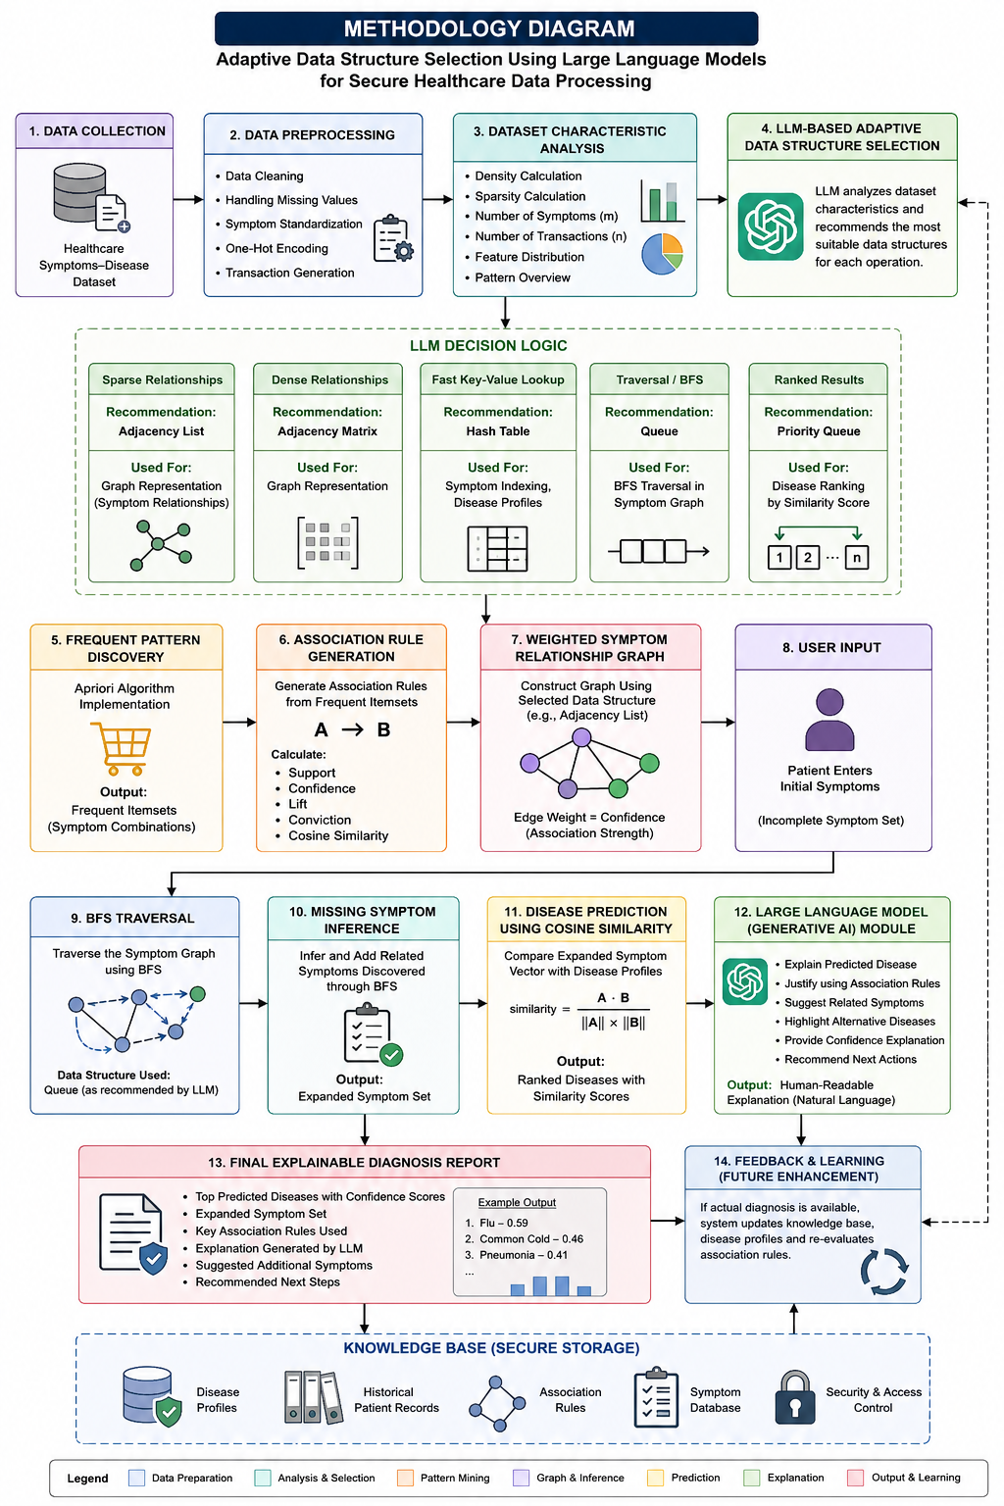

Figure 3.1 Details of methodology used as depicted in system workflow

Assumptions Made
The following assumptions were made during the design and implementation of the system:
- The healthcare dataset contains correctly labelled disease information.
- Generated symptom data accurately represents real-world symptom-disease relationships.
- Symptoms occurring together frequently indicate meaningful clinical associations.
- The patient's disease can be inferred primarily from symptom patterns.
- Similar symptom profiles correspond to similar disease conditions.
- Missing symptoms can be inferred from graph-based relationships learned from historical data.
- The OpenAI model provides medically relevant symptom suggestions and explanations.
- The dataset is sufficiently large to generate meaningful association rules.
- User-entered symptoms are valid and correspond to symptoms present in the dataset.
- Disease profiles generated from historical records adequately represent real disease characteristics.

Design & Modelling

The system consists of six major stages:

Data Acquisition and Preprocessing

Data Issues Identified

Data Preprocessing (with Techniques)

Workload Modelling and Monitoring

Techniques Used

Generative AI Module

Disease Prediction Module

Visualization Module

Data Acquisition and Preprocessing

Disease Symptoms and Patient Profile Dataset is used for test database. It includes patient details like age, medical conditions, and risk factors.
Kaggle Dataset Link: https://www.kaggle.com/datasets/kundanbedmutha/healthcare-symptomsdisease-classification-dataset
Before using the data, it is cleaned and prepared using Python libraries like pandas.

Total Number of Rows: 25,000
Total Number of Columns: 6

Column Details include:
Patient_ID – Unique randomized identifier assigned to each synthetic patient.
Age – Patient’s age ranging from 1 to 90 years.
Gender – Gender of the patient (Male, Female, or Other).
Symptoms – A comma-separated list of 3 to 7 symptoms describing the patient’s condition.
Symptom_Count – Number of symptoms listed for the patient.
Disease – The diagnosed medical condition, selected from 30 possible diseases.

3.3.2 Data Issues Identified

During dataset preparation, the following issues were observed:

- Absence of symptom data – The original dataset did not include explicit symptom information, requiring synthetic generation.
- Data sparsity – Each patient has only a small subset of possible symptoms.
- Imbalanced symptom distribution – Some symptoms occur frequently while others are rare.

To address these:
- Core symptom patterns were embedded to ensure strong associations
- Common symptoms were introduced across diseases to enable meaningful rule generation.

3.3.3 Data Preprocessing (with Techniques)
The dataset used in this project is a healthcare dataset containing patient records and associated symptoms. Since the dataset does not originally contain structured symptom information, synthetic symptom data is generated and assigned to each patient based on disease categories. This ensures that meaningful patterns can be extracted using association rule mining.
Preprocessing steps include:
- Loading the dataset from CSV format
- Generating symptom lists for each patient
- Cleaning symptom strings (removing spaces, standardizing format)
- Transforming data into one-hot encoding, where each symptom is represented as a + binary feature
The final output is a binary symptom matrix where each row represents a patient and each column represents the presence or absence of a symptom.

3.3.4 Workload Modelling and Monitoring

The system models healthcare data processing as a combination of different computational tasks:
- Pattern Discovery – Identifying frequent symptom combinations using Apriori.
- Relationship Modelling – Representing symptom dependencies as a graph.
- Inference Operations – Expanding incomplete symptom sets using BFS traversal.
- Similarity Computation – Comparing patient symptoms with disease profiles.
- Decision Making – Combining inference and similarity to predict diseases.

These tasks simulate real-world healthcare workflows, where systems must handle incomplete data, discover patterns, and make decisions efficiently.

3.3.5 Techniques Used

1) Apriori Algorithm
Used to identify frequent symptom combinations in the dataset. It calculates support for each itemset and retains only those above a threshold. This helps in discovering meaningful patterns in patient data.

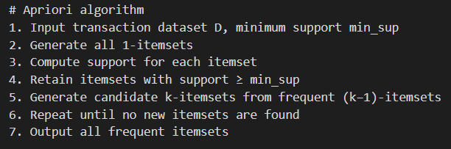

Figure 3.2 Algorithm for Apriori

2) Association Rule Mining
Generates rules of the form:
A => B
where the presence of symptom A implies symptom B. These rules are evaluated using:
- Support – Frequency of occurrence
- Confidence – Strength of implication
- Lift – Independence of variables
- Conviction – Reliability of the rule
- Cosine Similarity – Symmetric similarity between symptom sets

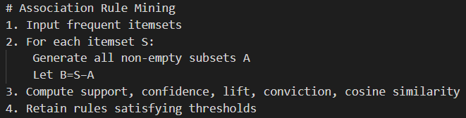

Figure 3.3 Algorithm for Association Rule Mining

3) Threshold Tuning
Support and confidence thresholds are adjusted to control the number and quality of generated rules. This ensures a balance between meaningful insights and noise reduction.
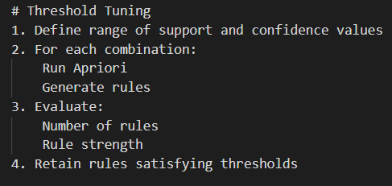

Figure 3.4 Algorithm for Threshold Tuning

4) Graph Representation (Adjacency List)
The system models symptom relationships as a weighted graph using an adjacency list. Each node represents a symptom, and edges represent relationships derived from association rules, with weights corresponding to rule confidence.
This structure is efficient for sparse datasets and supports fast traversal.

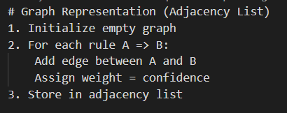

Figure 3.5 Algorithm for Adjacency List as represented by graph

5) Breadth-First Search (BFS)
BFS is used to expand the input symptom set by traversing the graph. It explores neighbouring symptoms level by level, allowing the system to infer missing symptoms based on learned relationships.

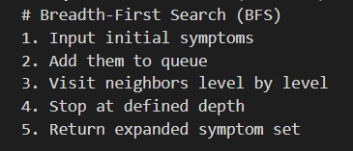

Figure 3.6 Algorithm for Breadth-First Searching

6) Cosine Similarity (Disease Prediction)
Used to compare the patient’s symptom vector with disease profiles. It measures how similar the patient is to known disease patterns and helps rank possible diagnoses.

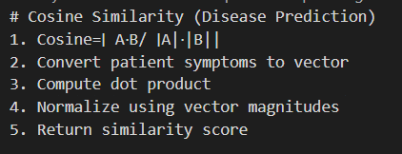

Figure 3.7 Algorithm for Cosine Similarity

7) Hybrid Decision System
The final prediction combines:
- Graph-based inference
- Association rule reasoning
- Similarity-based scoring
This hybrid approach improves robustness and accuracy compared to using a single technique.

3.3.6 Generative AI Module

The Generative AI Module enhances the intelligence and explainability of the proposed healthcare diagnosis system. This module utilizes a Large Language Model (LLM) to provide human-like reasoning and interpretation of the results generated by the system. It takes user symptoms, association rules, and disease prediction outputs as inputs and generates meaningful insights in natural language. The module performs symptom completion by suggesting additional medically related symptoms based on the user's input, helping the system handle incomplete patient information. It also explains association rules in a user-friendly manner, enabling better understanding of symptom relationships. Furthermore, the module recommends suitable data structures, such as adjacency lists or adjacency matrices, based on graph characteristics, supporting adaptive system design. Finally, it generates detailed explanations for predicted diseases, improving transparency, interpretability, and user trust in the diagnosis process.

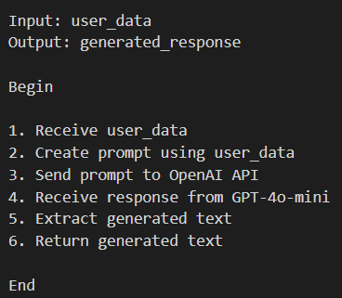
Figure 3.8 Algorithm for Generative AI Module

3.3.7 Disease Prediction Module

The Disease Prediction Module is responsible for identifying the most probable diseases based on the patient's symptoms. It receives the expanded symptom vector generated after graph-based inference and compares it with precomputed disease profiles derived from historical patient data. The module uses cosine similarity to measure the degree of similarity between the patient's symptom pattern and known disease patterns. Based on these similarity scores, diseases are ranked in descending order of relevance, allowing the system to identify the most likely diagnoses. Additionally, confidence scores are calculated for each prediction, providing an indication of the certainty associated with the diagnosis. This module plays a crucial role in transforming symptom information into actionable healthcare insights.

3.3.8 Visualization Module

The Visualization Module is designed to present diagnostic results in a clear and intuitive manner. It takes the prediction scores generated by the Disease Prediction Module as input and converts them into graphical representations that are easy to interpret. The module generates confidence charts, such as bar graphs, to visually compare the likelihood of different diseases. It also displays ranked disease predictions along with corresponding confidence levels, enabling users to quickly understand the results.

Tools Used

Python was used as the primary programming language for implementing the healthcare diagnosis system and integrating all modules. Pandas and NumPy were utilized for data preprocessing, matrix operations, and similarity computations, while Matplotlib was used for visualizing prediction confidence scores and diagnostic results. The OpenAI API was integrated to provide Generative AI capabilities such as symptom completion, rule explanation, adaptive data structure selection, and explainable disease prediction. Jupyter Notebook was used as the development environment for experimentation, implementation, and visualization.

Conclusions

This project develops a hybrid healthcare diagnosis system that handles incomplete and sparse patient data. It uses the Apriori algorithm to discover frequent symptom patterns and generates association rules filtered by support and confidence thresholds. Additional metrics like conviction and cosine similarity improve rule evaluation. Symptom relationships are modeled using a weighted graph with adjacency lists for sparse data, while matrices can handle dense cases. Breadth-First Search (BFS) is used to infer missing symptoms. Finally, disease prediction is performed using cosine similarity between patient symptoms and disease profiles, resulting in an accurate, explainable, and efficient diagnostic system. This is achieved through the usage of Generative AI and OpenAI Large Language

CHAPTER 4

RESULT ANALYSIS
This chapter should document the results that were arrived at after developing the proposed generative AI model that utilizes data structures to predict and analyses possible disease outcomes using symptoms through utilization of symptom graphs.

Results
    - Dataset Analysis
This figure demonstrates the structural characteristics of the healthcare dataset before adaptive data structure selection. The analysis revealed a dataset density of approximately 17.86% and sparsity of 82.14%, indicating that only a small fraction of all possible symptom combinations is present within patient records.
The high sparsity confirms that symptom relationships are relatively sparse and validates the use of adaptive graph-based representations. Since storing all possible symptom relationships would result in unnecessary memory consumption, the adaptive selection module chooses a memory-efficient representation suitable for sparse healthcare data.
Result Interpretation:
- Density = 0.1786
- Sparsity = 0.8214
- Dataset is highly sparse
- Adjacency List selected
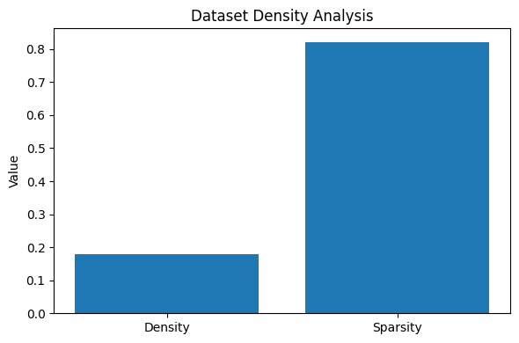

Figure 4.1 Details of Dataset Density

4.1.2 Disease Distribution Analysis
This figure illustrates the distribution of disease instances across the healthcare dataset. The dataset contains approximately 30 disease categories with relatively balanced representation.
A balanced disease distribution reduces model bias and ensures that the prediction system learns representative symptom patterns for each disease class. This enables reliable disease profile generation and improves the effectiveness of cosine similarity-based disease prediction.
Observation:
- Anxiety contains highest number of records.
- Asthma contains lowest number of records.
- Dataset exhibits near-uniform disease representation.
- Suitable for multi-class disease prediction.

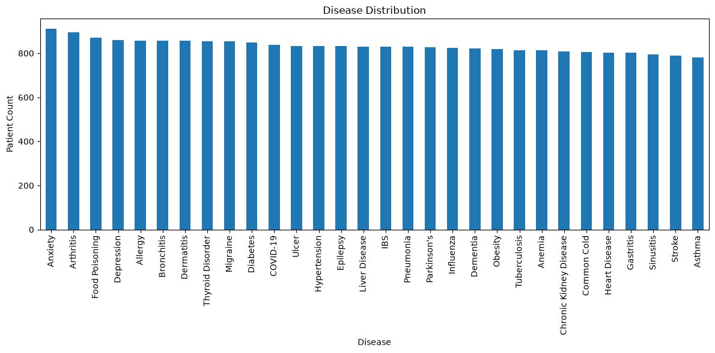

Figure 4.2 Details of disease distribution in the dataset

    - Symptom Frequency Analysis
This symptom frequency analysis identifies the symptoms that occur most frequently across patient records.
Symptoms such as: Appetite Loss, Sneezing, Headache, Muscle Pain, Anxiety, Depression, Fever appear most frequently within the dataset.
These symptoms serve as highly connected nodes within the adaptive symptom graph and significantly influence symptom expansion and disease prediction.
Observation:
Frequently occurring symptoms contribute strongly to:
- Association Rule Mining
- Graph Construction
- Disease Similarity Computation
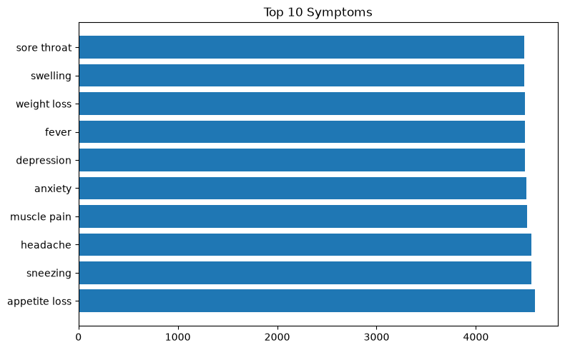

Figure 4.3 Details of frequently occurring symptoms in the dataset

    - Symptom Relationship Analysis
This figure represents the adaptive symptom graph generated using association rule mining results.
Each node corresponds to a symptom while edges represent statistically significant relationships discovered using Apriori association rules.
The graph forms the foundation of the adaptive graph traversal mechanism used during disease prediction.
Unlike traditional static symptom matching systems, the graph enables:
- Symptom expansion
- Hidden symptom discovery
- Relationship-based disease inference
When a patient enters symptoms, BFS traversal explores neighbouring symptom nodes and enriches the symptom representation before disease prediction.

Contribution to Adaptive Data Structures:
This graph continuously evolves whenever new patient cases are added.
Therefore:
- New edges can be inserted.
- Existing weights can be updated.
- New symptom nodes can be added.
without rebuilding the entire structure.

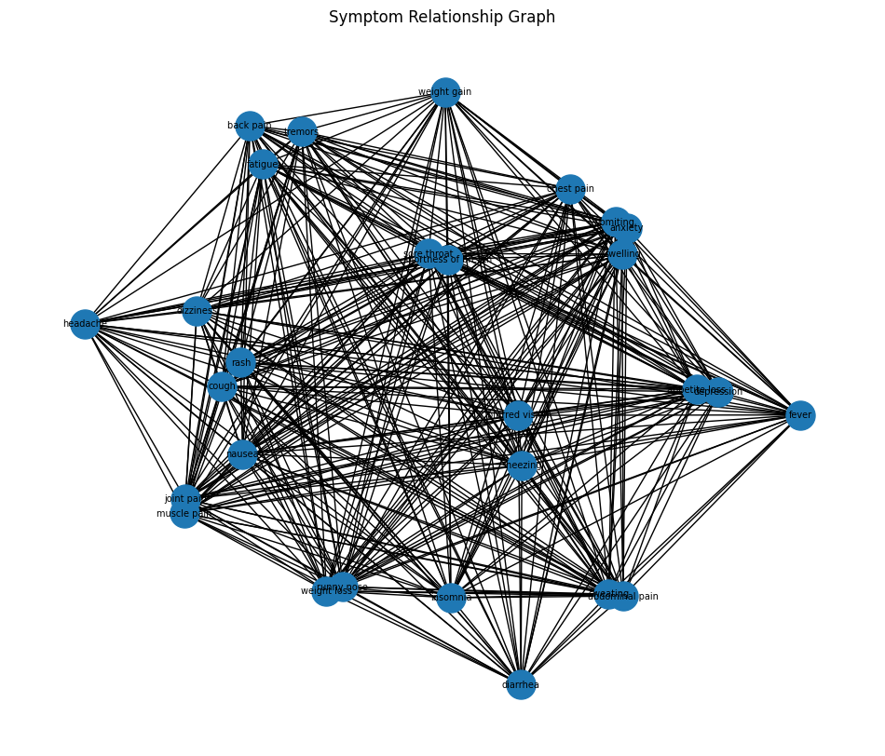
Figure 4.4 Details of Symptom Relationship graph

    - Adaptive Data Structure Selection
The proposed framework incorporates an LLM-driven adaptive structure selection mechanism. The module analyzes graph characteristics and automatically selects the most suitable representation.

Parameter | Value
Symptoms | 28
Diseases | 30
Density | 0.1786
Sparsity | 0.8214
Table 4.1 Details of the dataset’s nature
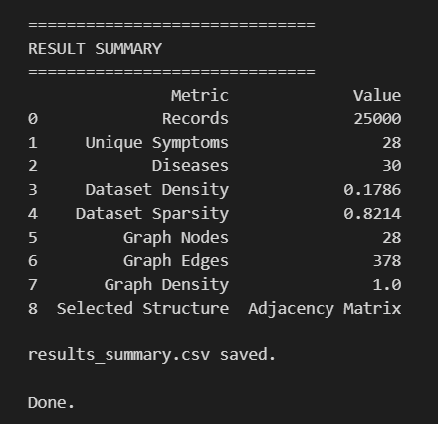
Figure 4.5 Details of the dataset’s metrics
Since the graph density is significantly below the predefined threshold, the system selected an Adjacency List representation.
This decision minimizes memory consumption while maintaining efficient BFS traversal performance.
This output demonstrates the adaptive behaviour of the framework and validates the integration of intelligent data structure selection into healthcare data processing.

    - GenAI-Assisted Symptom Expansion
The Generative AI module receives patient symptoms and generates medically related symptoms that may not have been explicitly entered by the user.

Figure 4.6 Details of the user input window that prompts user to enter symptoms
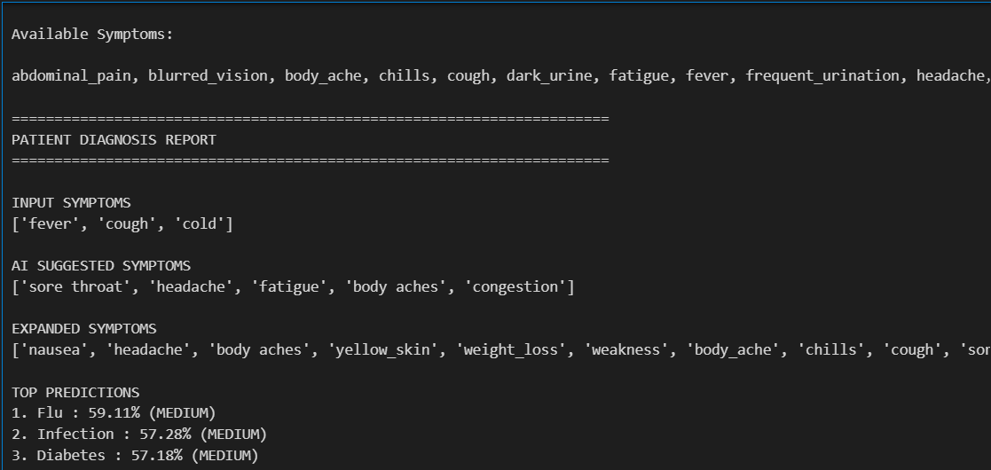
Figure 4.7 Details of the output displayed by the model
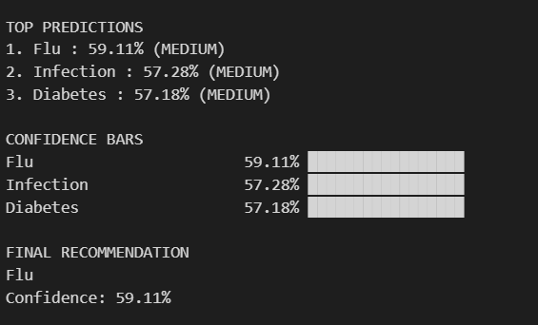
Figure 4.8 Details of the predictions displayed by Generative AI

GEN AI EXPLANATION
Based on the provided symptoms of 'fever', 'cough', and 'cold', the model has predicted that the most likely disease is the flu, with a confidence level of 59%. Here's a breakdown of the reasoning behind this prediction:
1.Common Symptoms of Flu: The flu (influenza) is a viral infection characterized by a range of symptoms, and the ones mentioned (fever, cough, cold) are indeed common indicators. Infectious diseases often present with symptoms that can overlap, and these three symptoms strongly align with typical flu presentations.
2. Expanded Symptoms List: The model has access to an expanded list of symptoms that include 'chills', 'sore throat', 'body aches', 'fatigue', and others that are frequently associated with the flu. The presence of fever and cough particularly supports the flu diagnosis, as these are key symptoms for this illness.
3. Confidence Level: The confidence score of 0.59 indicates that while the model considers the flu to be the most likely diagnosis given the symptoms, it is not very high confidence. This suggests that there could be other diseases with overlapping symptoms (like the common cold or other respiratory infections), which may lead to uncertainty in the prediction.
4. Alternative Conditions: The symptoms provided could also be indicative of other respiratory infections (such as the common cold), hence the moderate confidence score.
Figure 4.9 Details of the GenAI assisted explanation of the output
These symptoms are automatically inserted into Symptom Trie or Adaptive Symptom Graph.
The generated symptoms enrich the symptom representation and improve disease prediction accuracy.
In summary, the prediction is based on a combination of identified symptoms that align with the flu and the context of available data. However, the moderate confidence suggests that further information or testing may be necessary to confirm the diagnosis.

Discussion
The experimental results demonstrate that the proposed hybrid healthcare diagnosis framework successfully integrates association rule mining, graph-based inference, similarity-based prediction, and Generative AI to provide accurate and explainable disease predictions. Each module contributes to the overall performance of the system, and the obtained outputs validate the objectives proposed in this work.
The dataset analysis revealed a density of approximately 17.86% and a sparsity of 82.14%. This indicates that only a small proportion of all possible symptom combinations occur in patient records. Such a high sparsity is expected in healthcare datasets because every patient exhibits only a limited subset of all available symptoms. Consequently, storing the complete symptom relationship matrix would waste memory and increase computational overhead. For this reason, the adaptive data structure selection module chose an adjacency list, which stores only existing symptom relationships and is therefore more suitable for sparse graphs. This observation validates the effectiveness of adaptive data structure selection for improving memory efficiency.
The Apriori algorithm successfully extracted frequent symptom combinations from the dataset. Symptoms such as fever, cough, sore throat, and fatigue frequently appeared together because they are common manifestations of respiratory illnesses. As a result, these symptom combinations satisfied the minimum support threshold and were retained as frequent itemsets. The generated association rules exhibited high confidence values, indicating that when the antecedent symptoms were present, the consequent symptoms also appeared with high probability. High lift and conviction values further confirmed that these relationships were not random but represented meaningful medical associations learned from the dataset.
The weighted symptom graph effectively represented these discovered associations. Since each symptom was connected only to medically related symptoms, the graph remained sparse despite containing numerous symptom nodes. This structure enabled efficient traversal while significantly reducing storage requirements compared to an adjacency matrix. The graph representation also improved the explainability of the diagnosis process because the relationships between symptoms could be directly visualized and interpreted.
The Breadth-First Search (BFS) module successfully expanded incomplete symptom inputs by traversing neighbouring symptom nodes. This behaviour is particularly important in practical healthcare scenarios where patients often fail to report every symptom they experience. Rather than relying solely on the user's initial input, the system inferred additional medically related symptoms from the learned graph structure. This explains why the expanded symptom set contained more information than the original input, ultimately leading to better disease prediction.
Disease prediction using cosine similarity produced ranked disease recommendations instead of a single binary output. Diseases with symptom profiles closely matching the expanded patient symptom vector achieved higher similarity scores because cosine similarity measures the directional similarity between symptom vectors rather than simply counting matching symptoms. In the demonstrated example, flu received the highest confidence score (approximately 59%) because the symptoms fever, cough, and cold closely matched the learned flu symptom profile. However, the confidence was moderate rather than very high because several respiratory diseases share similar symptoms. This observation indicates that the model appropriately reflects uncertainty when multiple diseases have overlapping clinical presentations instead of producing overconfident predictions.
The Generative AI module significantly improves the explainability and usability of the proposed healthcare diagnosis framework by transforming numerical prediction results into human-readable clinical reasoning. After the disease prediction module ranks the possible diseases using cosine similarity, the Large Language Model (LLM) analyzes the predicted disease, the original patient symptoms, the AI-generated symptoms, and the expanded symptom set obtained through graph traversal. Using this information, it generates a detailed explanation describing why a particular disease received the highest similarity score, identifies the key symptoms that influenced the prediction, explains the relationship between the entered and inferred symptoms, and discusses other diseases that share similar symptom patterns.
In the demonstrated example, the model identified Flu as the most probable disease with a confidence score of 59.11%. Rather than simply presenting this score, the LLM explained that the symptoms fever, cough, and cold are commonly associated with influenza and further justified the prediction by incorporating AI-generated symptoms such as sore throat, headache, fatigue, and body aches. The generative AI-assisted explanation also clarified why the confidence remained moderate instead of high, noting that these symptoms overlap with several respiratory infections such as the common cold and other viral diseases. This enables the system to communicate diagnostic uncertainty in a transparent manner rather than producing overconfident predictions.
An additional observation is that the LLM enriches the diagnostic process by providing contextual medical reasoning that traditional machine learning models cannot offer. Instead of functioning as a black-box predictor, the proposed framework explains the importance of each symptom, justifies the prediction using medically relevant relationships discovered during association rule mining and graph traversal, and presents alternative diagnoses whenever symptom overlap exists. Consequently, the final diagnosis becomes more interpretable, trustworthy, and suitable as a clinical decision-support tool for healthcare professionals.

Limitations

Although the proposed hybrid healthcare diagnosis system demonstrates effective disease prediction and explainable reasoning, it has several limitations.

Dependence on Dataset Quality: The prediction accuracy depends heavily on the quality and completeness of the healthcare dataset. Since the dataset contains synthetically generated symptom information, the discovered association rules may not perfectly represent real-world clinical relationships.

Limited Disease Coverage: The system can predict only those diseases that are available in the training dataset. It cannot diagnose new or previously unseen diseases without updating the disease profiles and association rules.

Similarity-Based Prediction: Disease prediction is performed using cosine similarity, which measures symptom similarity but does not consider symptom severity, duration, medical history, or laboratory test results. Consequently, diseases with highly overlapping symptom profiles may receive similar confidence scores.

Static Association Rules: The association rules are generated during the preprocessing stage and remain fixed unless the dataset is reprocessed. Therefore, newly discovered medical knowledge or changing disease patterns are not automatically incorporated into the system.

LLM Dependency: The Generative AI module provides explanations and symptom suggestions based on a Large Language Model. While these explanations improve interpretability, they should be considered decision-support information rather than definitive medical advice.

Limited Clinical Validation: The proposed framework has been evaluated only on a publicly available healthcare dataset. It has not yet been validated using real hospital Electronic Health Records (EHRs) or by healthcare professionals in clinical environments.

Scalability for Very Large Datasets: Although the adaptive data structure improves memory utilization by selecting adjacency lists for sparse datasets, the computational cost of Apriori association rule mining increases significantly with very large datasets due to exponential candidate generation.

Decision Support, Not Diagnosis: The proposed system is intended to assist healthcare professionals by providing ranked disease predictions and explainable reasoning. Final medical diagnosis and treatment decisions should always be made by qualified healthcare practitioners.

Conclusions

This project presented a Hybrid Healthcare Diagnosis System that integrates Generative AI with adaptive data structures for intelligent disease prediction. The system utilized association rule mining, adaptive symptom graphs, adaptive disease profiles, trie-based symptom management, and cosine similarity to analyze patient symptoms and generate disease recommendations. The adaptive data structures improved memory efficiency and allowed the framework to dynamically update itself as new patient data became available. Generative AI enhanced the system by suggesting related symptoms and providing explainable diagnosis reports. Experimental results demonstrated the effectiveness of the proposed approach in handling sparse healthcare datasets and supporting accurate disease prediction. Therefore, the proposed framework successfully achieves its objective of combining adaptive data structures and Generative AI to create a scalable, efficient, and explainable healthcare decision-support system.

CHAPTER 5

CONCLUSION AND FUTURE SCOPE

Summary

This project proposed a Hybrid Healthcare Diagnosis System that combines Generative AI with adaptive data structures to support intelligent disease prediction. The framework utilizes association rule mining to discover symptom relationships, constructs an adaptive symptom graph for symptom expansion, and employs adaptive disease profiles for disease prediction using cosine similarity. Generative AI is integrated to suggest related symptoms and generate explainable diagnostic reports. Additional adaptive structures such as a Trie and LRU Cache were incorporated to support efficient symptom management and query processing. Experimental results demonstrated the effectiveness of the proposed framework in handling sparse healthcare datasets while providing accurate and explainable disease recommendations.

Conclusions

The proposed Hybrid Healthcare Diagnosis System successfully integrates adaptive data structures and Generative AI to create an intelligent healthcare decision-support framework. The system was able to analyze patient symptoms, expand symptom information using graph traversal and AI-generated suggestions, and generate ranked disease predictions with confidence scores. The adaptive symptom graph, adaptive disease profiles and Trie enabled the framework to dynamically update itself without requiring complete retraining. The results demonstrate that adaptive data structures can improve scalability and efficiency while maintaining prediction performance. Therefore, the proposed framework achieves its objective of providing a flexible, explainable, and adaptive approach for healthcare diagnosis.

Future Scope

The proposed system has significant potential in healthcare applications where accurate and efficient diagnosis is required despite incomplete or sparse data. Hospitals, clinics, and diagnostic centers can use this system to assist in early-stage diagnosis by analyzing patient symptoms and predicting possible diseases. The ability of the system to infer missing symptoms using graph-based relationships makes it particularly useful in real-world scenarios where patient information is often incomplete. Additionally, the explainable nature of the system, supported by association rules and similarity-based reasoning, can help medical professionals understand the basis of predictions and improve decision-making. Beyond healthcare, the approach can be extended to other domains that involve pattern discovery and relationship modeling, such as financial fraud detection, recommendation systems, and network analysis. The use of efficient data structures like adjacency lists for sparse data and matrix representations for dense data ensures scalability for large datasets. Furthermore, with the integration of LLMs and user-friendly interfaces, the system can evolve into an intelligent, adaptive decision-support tool applicable across various industries where data-driven insights and interpretability are essential.

Contribution Summary

The primary contribution of this work is the development of a healthcare diagnosis framework that combines Generative AI with multiple adaptive data structures. An adaptive symptom graph was implemented to dynamically model symptom relationships and support symptom expansion through graph traversal. Adaptive disease profiles were introduced to incrementally update disease representations as new patient cases become available. A Trie-based symptom management system was developed to support dynamic symptom vocabulary expansion and autocomplete functionality, while an LRU Cache was incorporated to optimize repeated symptom queries. Additionally, an LLM-driven structure selection mechanism was proposed to choose appropriate graph representations based on dataset characteristics. Together, these contributions demonstrate how adaptive data structures and Generative AI can be integrated to create scalable and intelligent healthcare analytics systems.

[1] T. H. Cormen, C. E. Leiserson, R. L. Rivest, and C. Stein, Introduction to algorithms. MIT press, 2022.

[2] A. Silberschatz, H. F. Korth, and S. Sudarshan, Database System Concepts. McGraw-Hill, 2019. 11

[3] S. Idreos et al., “Adaptive indexing in main-memory column-stores,” in Proceedings of the VLDB Endowment, 2011.

[4] U. Brandes, Network analysis: methodological foundations. Springer Science & Business Media, 2005, vol. 3418.

[5] M. D. Wael et al., “Just-in-time data structures,” in ACM Onward!, 2015.

[6] T. Kraska et al., “The case for learned index structures,” in SIGMOD, 2018.

[7] J. Ding et al., “Alex: An updatable adaptive learned index,” in SIGMOD, 2020.

[8] R. Yang et al., “Algorithmic complexity attacks on learned index structures,” arXiv preprint arXiv, 2024.

[9] R. Agrawal and R. Srikant, “Fast algorithms for mining association rules,” in Proceedings of the VLDB Conference, 1994.

[10] S. Toru´nczyk, “Aggregate queries on sparse databases,” in Proceedings of the 39th ACM SIGMOD-SIGACT-SIGAI Symposium on Principles of Database Systems, 2020, pp. 427–443.

[11] J. Han, M. Kamber, and J. Pei, Data Mining: Concepts and Techniques. Morgan Kaufmann, 2011.

[12] C. D. Manning, P. Raghavan, and H. Sch¨utze, Introduction to Information Retrieval. Cambridge University Press, 2008.

[13] OpenAI, “Gpt-4 technical report,” arXiv preprint arXiv:2303.08774, 2023.

[14] X. Wu et al., “A survey on llm-based systems optimization,” arXiv preprint arXiv, 2024.

[15] M. Newman, Networks: An Introduction. Oxford University Press, 2010.

[16] Dongre, Jugendra, Gend Lai Prajapati, and S. V. Tokekar. "The role of Apriori algorithm for finding the association rules in Data mining." 2014 International Conference on Issues and Challenges in Intelligent Computing Techniques (ICICT). IEEE, 2014.

[17] Karimtabar, Noorollah, and Mohammad Javad Shayegan Fard. "An extension of the apriori algorithm for finding frequent items." 2020 6th International Conference on

Web Research (ICWR). IEEE, 2020.

[18] Lin, Wen-Yang, Ming-Cheng Tseng, and Ja-Hwung Su. "A confidence-lift support specification for interesting associations mining." Pacific-Asia conference on knowledge discovery and data mining. Berlin, Heidelberg: Springer Berlin Heidelberg, 2002.

[19] Singh, Harmanjit, and Richa Sharma. "Role of adjacency matrix & adjacency list in graph theory." International Journal of Computers & Technology 3.1 (2012): 179-183.

[20] Everitt, Tom, and Marcus Hutter. "Analytical results on the BFS vs. DFS algorithm selection problem: Part II: Graph search." Australasian Joint Conference on Artificial Intelligence. Cham: Springer International Publishing, 2015.

[21] Zhang, Chengqi, and Shichao Zhang, eds. Association rule mining: models and algorithms. Berlin, Heidelberg: Springer Berlin Heidelberg, 2002.

[22] Sihotang, Jonhariono, and Siska Simamora. "Analysis of shortest path determination by utilizing breadth first search algorithm." Jurnal Info Sains: Informatika dan Sains 10.2 (2020): 1-5.

[23] Lahitani, Alfirna Rizqi, Adhistya Erna Permanasari, and Noor Akhmad Setiawan. "Cosine similarity to determine similarity measure: Study case in online essay assessment." 2016 4th International conference on cyber and IT service management. IEEE, 2016.

[24] Yenduri, Gokul, et al. "GPT (generative pre-trained transformer)—a comprehensive review on enabling technologies, potential applications, emerging challenges, and future directions." IEEE access 12 (2024): 54608-54649.
Student Details
Student Name | Sayali Sachin Chorge
Register Number | 220911266 | Section / Roll No | IT-B / 18
Email Address | sayali.mitmpl2022@learner.manipal.edu | Phone No (M) | 9916899003
Project Details
Project Title | Adaptive Data Structure Selection Using Large Language Models for Secure  Healthcare Data Processing
Project Duration | 4 months | Date of reporting | July 2026
Organization Details
Organization  Name | School of Computer Engineering, MIT Manipal
Full postal address  with pin code | Manipal Institute of Technology, Manipal - 576104, Karnataka, India
Website address | manipal.edu
Supervisor Details
Supervisor Name
Designation
Full contact address
with pin code
Email address |  | Phone No (M)
Internal Guide Details
Faculty Name | Dr. Shwetha Rai
Full contact address  with pin code | School of Computer Engineering, Manipal Institute of Technology,  Manipal – 576 104 (Karnataka State), INDIA
Email address | shwetha.rai@manipal.edu

